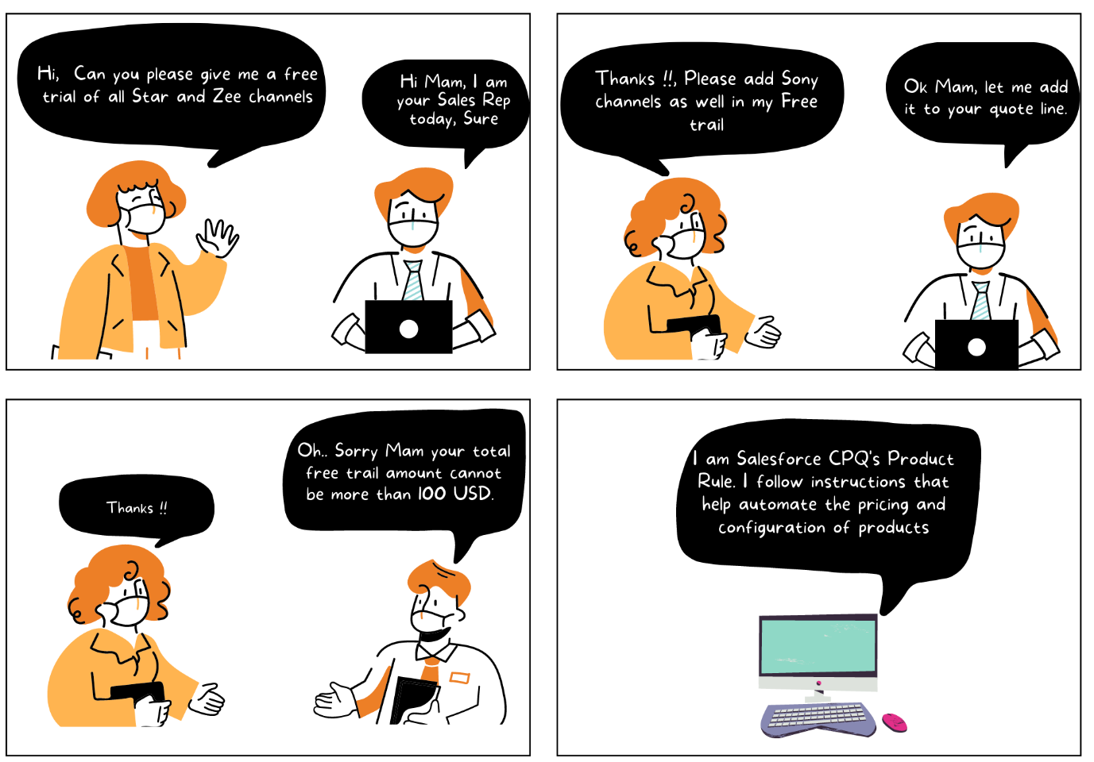

**Product Rules:**

* Product Rules are a set of conditions and actions that help you automate and customize the pricing and configuration of products.
* Think of it like a set of instructions that the CPQ system follows when determining how to price and configure a product. These rules are based on specific conditions or criteria that you define, and they trigger specific actions or changes in the quote or product configuration.
* Product rules are derived based on the if/then structure. If a condition is satisfied, then an action will be performed. Product rules allow admins to define advanced configuration logic compared to option constraints. We can show/hide specific product options that are more resource-intensive.

**Some Considerations of Product Rules:**

* Salesforce CPQ and its product rules are designed to help sales reps get the right products on the quote the first time. Think of product rules as guardrails to help sales reps stay on course when navigating complex combinations of products and services.
* Product rules are often related to bundles, But can also work on Quote level
* Product rules allow us to define advanced configuration logic, compared to option constraints.
* For example, Show and add/hide and remove product options are possible with the product rule
* Product rules can be more resource intensive.

**Type of Product Rules-**

In the Product Rule record, there is a field called Type. It is a picklist field. Based on that there are four types of Product Rules (*we will discuss in depth each of them in the next posts*):

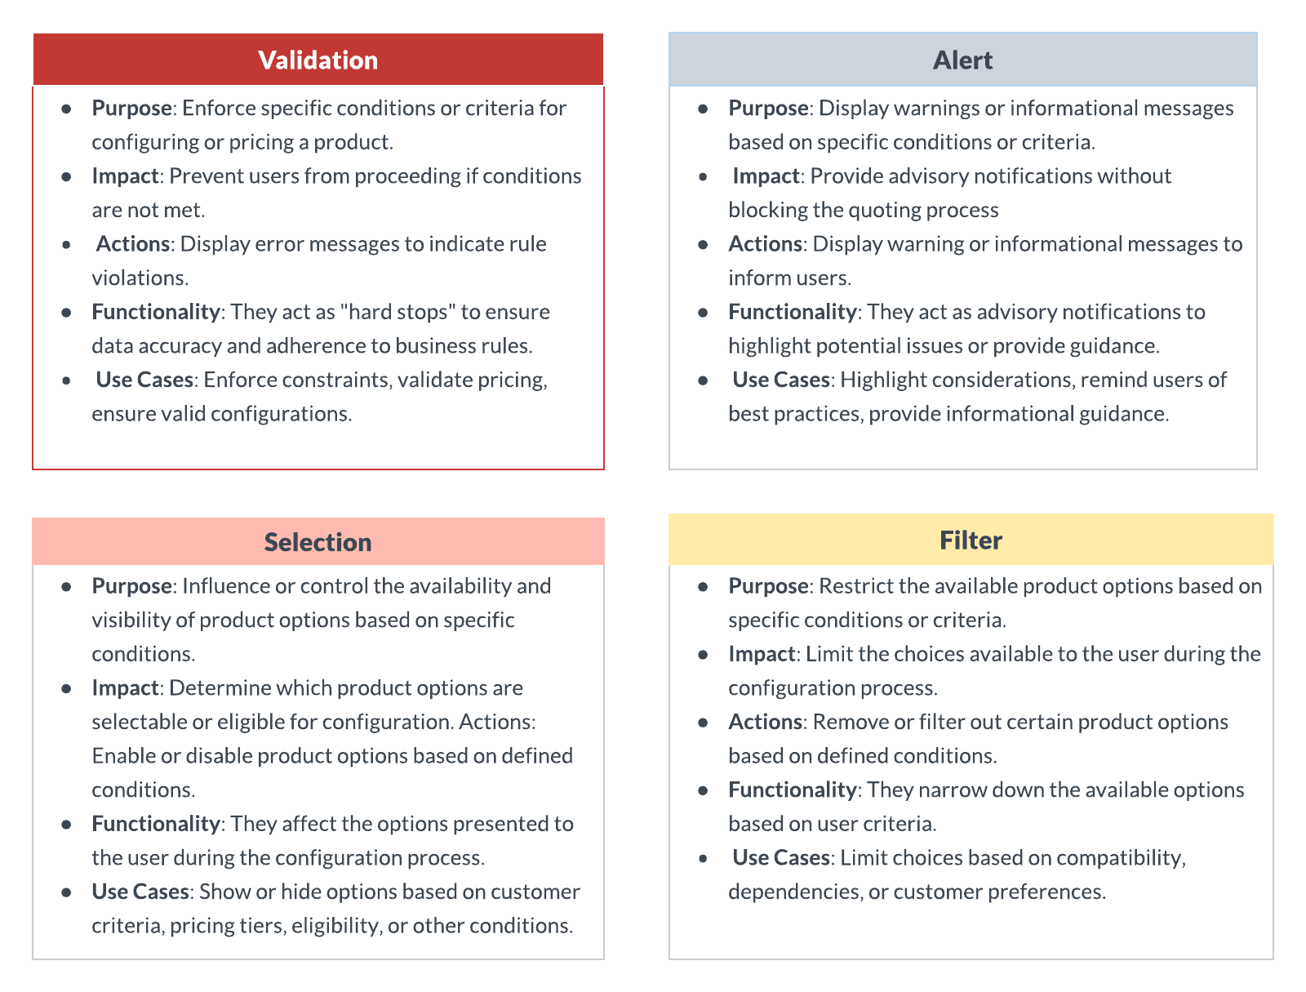

1. **Validation**: This prevents the rep from saving a record until the error is corrected. For example, when you are selling a laptop without a power cord, it stops the rep from saving the incorrect configuration until the right products are added.
2. **Alert:**These are like soft alerts, where the system will warn the rep that a required product is missing but will still allow them to save the record. For example, when your rep is selling a laptop, the system will provide an alert that the mouse is missing but the sales rep can still decide whether to include a mouse, and the system will not have a hard stop.
3. **Selection:**Selection rules work with the product option configurations for selected products to provide more dynamic and specific bundle configurations. It automatically performs actions on product options without displaying any message. Selection adds, removes, or hides products during bundle configuration.  
   For instance, when a rep is selling a laptop, mandatory products such as the power cord will be automatically added to the configuration. This overrides the product bundle option while adding the products.
4. **Filter:**Allows specific products in a feature that uses the dynamic selection option. For example, when a US sales rep is creating a quote, it shows only US-compatible products in the configuration

**Contributing Objects for Product Rules:**

1. **Product Rule**: The phrase product rule has two meanings. First, it's meant to describe the concept of business logic that helps sales reps get the right products onto the quote. Second, it refers to the actual object named product rule.
2. **Error Condition**: This defines the condition for which the product rule should be executed. Product Action: This defines how CPQ changes the bundle configuration. Product Action performs an action on a product option, such as selecting or deselecting the option within the bundle.
3. **Lookup Query**: This is used in product rules to query data from an object (both standard and custom objects) other than a quote. They map the data from the lookup object back to the product rule.
4. **Configuration Rule**: This links the product rule with a bundle or individual product.
5. **Summary Variable**: A summary variable is a way of aggregating data. Be mindful of the number of summary variables. It should not be more than 5 or 10 per rule. Excessive use may result in performance issues and governor issues.
6. **Configuration Attribute**: This is a field that the sales rep can set during the product configuration. These are not part of product rules, but they are used in error conditions and sometimes in lookup queries.

Interview Questions:

1. What is the use of Product Rules?
2. Business don’t want to stop Sales reps to add any product but they want to show them a alert message when ever they add more than 100 USD free product. How can we do that?
3. Based on user profile business wants to show the products to the sales reps. Is it possible? How can we do that?